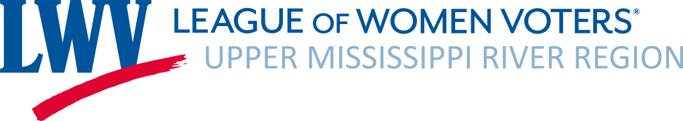

Treasurer’s Report
February 5, 2024

- Operating: December 2023, January 2024 Activity
  - Revenues:
$25.00 Membership
$2.70 Interest Income
Total Revenue $27.70
  - Expenses:
$25.00 Wisconsin State Tax Exemption Registration Fee
$.99 PayPal Fee
$333.18 Education Speaker Honorariums
Total Expenses: $359.17
Net Operating Revenue $331.47

- Bank balance as of November 30, 2023: $12,380.15
- (includes ERC Grant and Judy Beck Memorial Fund)
  - Judy Beck Memorial Fund balance (generally for advocacy activities): $.00*
  - ERC Restricted Grant II balance: $00 Used $166.82 to pay Speaker Honorariums
- Current 2023-24 memberships: 40 Members as of 1/31/2024
- 2024 MRN Mini Grant to Promote Clean Water $10,000 check pending.
- Budget Committee Appointments
- Included with Treasurer’s Report:
  - Budget Vs. Actuals YTD July 2023 – January 2024
  - Volunteer Hours Log
  - Example Volunteer Hours Log – Catherine’s 2023/24 Hours Log
Balance Sheet as of 1/31/2024
ASSETS
Checking Account | $7,012.21
Savings Account | $5,367.94
TOTAL ASSETS | $12,380.15
LIABILITIES | $0.00
EQUITY
ERC Restricted Grant II | .00
Judy Beck Memorial Fund | .00
TOTAL LIABILITIES & EQUITY | $12,380.15

